Low Level Design Template

DMT/AD06/TMP

Project Code
Project Name | SHARE MARKET

Prepared/Modified by | Role | Date of Preparation
ANITA MAHATO  AVINASH BADIGAR  MRUNAL DUSHANE  SNEHA OVHAL  SWETA BISWAL | TEAM LEADER  TEAM MEMBER  TEAM MEMBER  TEAM MEMBER  TEAM MEMBER
Reviewed by | Role | Date of Review
Approved by | Role | Date of Approval
Circulation List |  | Version Number of the template:1.0
Version Number | <version No >

Table of Contents

1. Description Of The Unit 3
2. References 4
3. Dependencies / Assumptions 5
4. Class Diagrams 6
5. Sequence Diagrams 7
6. Design Components 8
6.1 List Of UI Components 8
6.2 List Of Design Classes 8
7. Re-Usable Routines/Components 9
8. Messages 10
9. Configuration Files 11
10. Crud Matrix Table 12
11. Data Mapping Matrix 13
12. Action Flow Matrix 14
13. Stored Procedures 15
14. Program Specification / Pseudo Code 16
REVISION HISTORY OF THE WORK PRODUCT 17

Description Of The Unit

‘’Money Control Stock Market’’ is a Financial information source. It manages your finance with our online Investment Portfolio, live stock price , share details, share price , companies shares details , analysis on Equity , share stock and share price.

- Providing service from online trading.

- Research to array of various shares present in market.

- Proving knowledge of the share stock present in market.

- Statistics of different shares present in the market.

- Providing 3 types of exchange i.e

- NSE
- BSE
- COMMODITY
- We are providing order type i.e. buying and selling of shares.

USER :

- User will be able to sign up to his/her account to buy or sell shares.

- User is not registered then he/she will be directed to the sign up page where user will provide own details and password.

- User can browse the details of the share and market and even user can update, add and delete details as well.

- Can gather information about the shares and according to that user can buy or sell shares.

- User can view his own account and even they can see their transaction details.

- If any problem is there during any process then a automatic error message will display.

- User can create account under brokers account only.

- Only broker can add user into his account.

BROKER :

- Broker will add user into his account.

- Broker can browse into user account.

- Broker can be added under the Money Control share market.

- Broker can update, add & delete details of the user.

- Broker can update, add and delete his own account.

- Broker can browse his previous transactions that has been done.

- Broker can browse and maintain the details of the user.

- Broker can directly sell and buy shares for himself and for the user as well.

Dependencies / Assumptions

- One user is having one account.

- User can buy multiple share and even purchase multiple share.

- Broker will access all the users account.

FLOW DIAGRAM

MONEY CONTROL SHARE MARKET

---------------------------------------------------

BROKER USER

OPERATIONS
VIEW
UPDATE / DELETE
REPORT GENERATION

SCREENS

1.LOGIN PAGE :

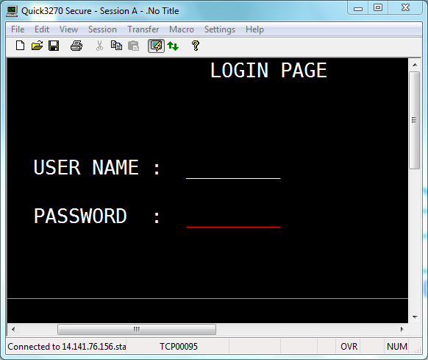

2. MAIN MENU

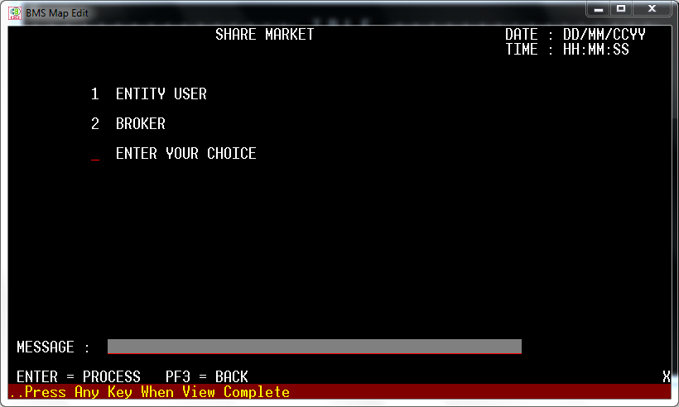

3. ENTITY MENU MAP

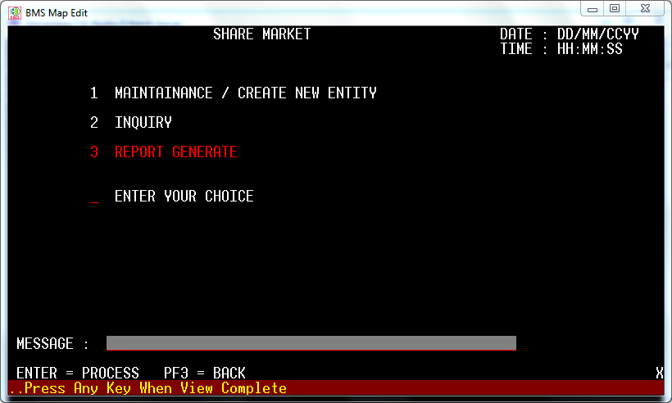

MAINTAINANCE AND CREATE NEW ENTITY

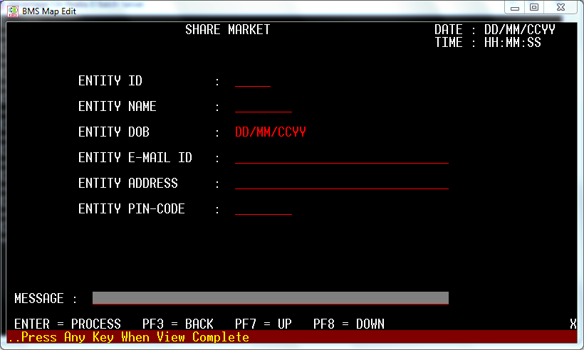

5.ENTITY SHARE HOLDING

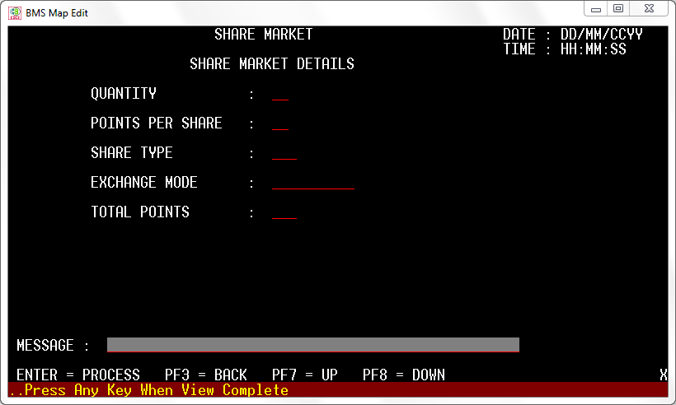

BROKER FLOW MAP

